

# USCCB Word of Life Bulletin Series & Intercessions

English:

Spanish:

**Not available at time of printing:** [**Word of Life | Respect Life**](https://www.respectlife.org/word-of-life)

Office of Human Life & Dignity’s Webpage Links

[www.archindy.org/humanlifeanddignity](http://www.archindy.org/humanlifeanddignity/index.html)

[**Birthline Ministry**](http://www.archindy.org/humanlifeanddignity/ministries-birthline.html) [**Project Rachel**](http://www.archindy.org/humanlifeanddignity/past-abortion.html)

[Health Ministry](http://www.archindy.org/humanlifeanddignity/ministries-health.html)  [Hospice & Palliative Care](http://www.archindy.org/humanlifeanddignity/hospice.html)

[**Mental Health**](http://www.archindy.org/humanlifeanddignity/mental-health.html)  [Religious Freedom](https://www.usccb.org/committees/religious-liberty)

[Corrections Ministry](http://www.archindy.org/corrections/index.html)  [Observance of Roe vs. Wade](http://www.archindy.org/humanlifeanddignity/ministries-local-solemn-observance.html)

[Substance Addiction Ministry (SAM)](http://www.archindy.org/humanlifeanddignity/ministries-sam.html)

**Extras:**

* Vigil for Life
* March for Life
* Black Catholic Community
* French Mass, St. Monica
* Philippine Ministry – Simbang Gabi

[**Brie Anne Varick**](mailto:bvarick@archindy.org) **– Director, Human Life & Dignity**

[**Keri Carroll**](mailto:birthline@archindy.org) **– Coordinator, Birthline Ministry**

[**Deacon Marc Kellams**](mailto:mkellams@archindy.org) **– Coordinator, Corrections Ministry**

December 2021

January 2022

Monthly Bulletin

Announcements

*Archdiocese of Indianapolis*

*Office of Human Life & Dignity*

Please consider sharing these announcements with your parishioners through your weekly bulletin.

If your parish has **Human Life & Dignity** event you want other parishes to know about, please submit them to Keri Carroll by email: [kcarroll@archindy.org](mailto:kcarroll@archindy.org)

**Visit** <https://archindy.org/humanlifeanddignity/BulletinandNewsletters.html> to view the PDF these announcements.

[RSVP](https://www.eventbrite.com/e/vigil-for-life-tickets-190646527897)

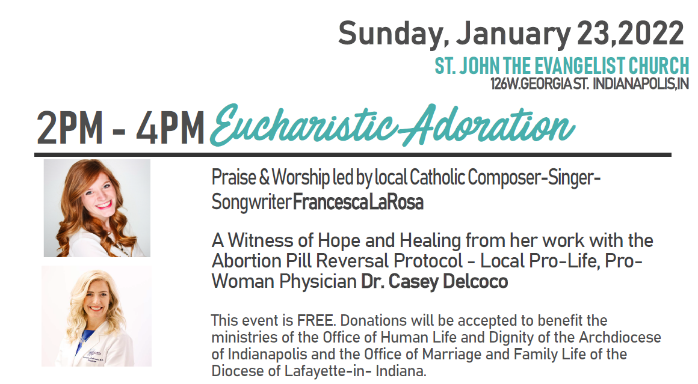

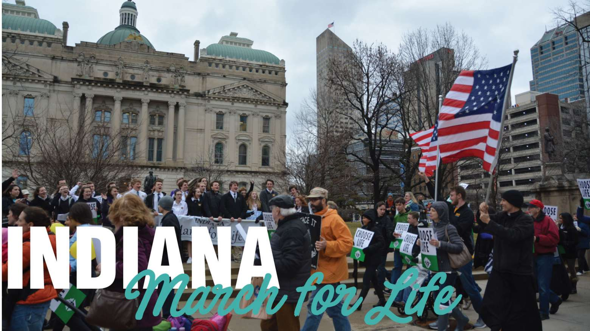

[RSVP](https://www.eventbrite.com/e/indiana-march-for-life-tickets-191879495737)

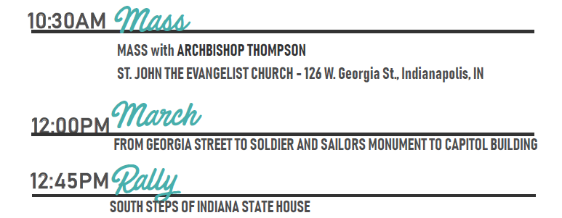

**Holiday Closures at Birthline**

* **November 17th – closed 11:30 – 5:00 pm for Volunteer Appreciation Lunch**
* **November 22nd – 26th – closed for Thanksgiving**
* **December 8th - closed at 11:30 – 5:00 pm Catholic Center Mass at noon**
* **December 20th – 31st – closed for the Christmas Holiday**

**No Donations will be received during closures**

**Birthline will reopen on January 3rd**

# *Birthline Ministry*

*Keri Carroll, Coordinator*

***Birthline is a ministry of the Office of Human Life & Dignity which provides baby layettes for moms in need.***

We are currently receivingdonations which are accepted **on Monday & Wednesday from 10:00 am – 2:30 (closed from Noon – 1:00 pm)** at the **Xavier Building (Crisis Center’s main entrance on Northside of building – 1435 Illinois Street, Indianapolis 46202**)

* ***Birthline is GROWING and needs Volunteers. Have you ever thought about being a volunteer? Birthline is currently looking for Volunteers*** to help on **Monday and Wednesday** at the Xavier Building to prepare layettes, assist clients, and sort donations. Bi-lingual is a plus. Training is provided.
* ***Are Monday & Wednesday not good for you, we now have available volunteer times on Tuesdays from 9 am – noon. Please contact Keri Carroll at 317-236-1433 for more information.***
* **\*\*Currently in need of volunteers on Monday afternoons from 12:30 – 2:30 pm\*\***
* ***Needed: Scheduling Volunteers to*** help monitor the phones and schedule clients from your home. Training is provided. Must have a computer with internet access.
* ***Needed: Joe-Handyman*** to helpon Monday and/or Wednesday anytime between 9:00 am – 2:30 pm to accept and evaluate the donations coming in, to assist clients with layettes back to their cars, and general labor in a working environment.

If you are available to help in this ministry please contact Keri Carroll, at (317) 236-1433 or [**birthline@archindy.org**](mailto:birthline@archindy.org)

**Wish List**

**Urgent Items Needed:**

**Fall & Winter clothes** – Sizes 0-3 mo. through 2T for boys and girls

**Pajamas** – Sizes 12mo, 18mo, 24mo, & 2T for boys and girls

**Diapers** – Sizes 4, 5 and 6

**Ongoing Needs:**

**Baby Wash **Diaper Cream

Pacifiers Bibs

Baby Books Sippy Cups

Bottles Wipes

**Rosaries**

**Needed: Maternity Clothes - sizes Large, X-Large and 2X-Large**

**(Must be maternity clothes not large clothes)**

**December 2021 - Events Around the Archdiocese**

**December 3, 2021: Women’s Care Center First Friday Mass**

The Women's Care Center (4901 West 86th Street Indianapolis 46268) invites you to our **First Friday Mass** on **December 3rd** at 5:00 pm in our chapel. There will be light refreshments after Mass and the ability to take a tour and learn more about our mission. We are now serving over 30 women facing unplanned pregnancies many days, most of who benefit from multiple services, such as pregnancy tests, ultrasounds, parenting classes, and goals counseling. We are so grateful to be able to serve the women who walk through our door. If you have questions please contact Jenny Hubbard, Director, at (317) 509-9596. We hope to see you there!

**December 15, 2021: Respect Life Mass – Terre Haute**

**December 15th** the 3rd Wednesday of the month, please consider joining the St. Joseph Respect Life Ministry in praying the Divine Mercy Chaplet (St. Joseph University, 113 S Fifth St., Terre Haute) at 4:45 pm prior to the 5:15 pm Respect Life Mass. For more information, contact the parish office at (812) 232-7011. For more information, please contact Amy Langham at [**amylou0330@gmail.com**](mailto:amylou0330@gmail.com) or the parish office at 812-232-7011.

**December 16, 2021: Pray for an End to Abortion and Sins Against Life Adoration**

Please join us for Adoration of the Blessed Sacrament is held at **St. Joseph Catholic Church**, (1401 South Mickley Avenue, Indianapolis, IN 46241) on **every third Thursday** – **December 16th** from 11:00 am – 7:00 pm to pray specifically for Gabriel Project’s mothers and babies, for an end to abortion, and sin against life, and for the closing of Clinic for Women abortion facility location at 3607 West 16th Street, and for a return to a “Culture of Life.” For more information contact Patty Arthur, St. Joseph’s Pro-Life Ministry coordinator at (317) 244-9002 or [**patty.arthur@aol.com**](mailto:patty.arthur@aol.com) or visit website: [**http://www.stjosephindy.org**](https://nam02.safelinks.protection.outlook.com/?url=http%3A%2F%2Fwww.stjosephindy.org%2F&data=02%7C01%7C%7C7516bd9c1971410e21b208d6b82ae91e%7Ca54192d98f824167ba15f0159a5c6254%7C0%7C0%7C636898892163329210&sdata=IkRX9peybIsR2FYRaRlRm9kz8FuNSJRTkobDebFzI7Q%3D&reserved=0)**.**

**Faithful Citizens Rosary Walks**

The walks will resume in **March 2022**. For more information contact Eric at [**faithful.citizens2016@gmail.com**](mailto:faithful.citizens2016@gmail.com)**.**

*Faithful Citizens Rosary Walks is sponsored by the Pro-Life Ministry of Our Lady of the Most Holy   
Rosary Catholic Church. For more details, email:* [*holyrosary.prolife@gmail.com*](mailto:holyrosary.prolife@gmail.com)

**December 18, 2021 Helpers of God’s Precious Infants, St. Michael the Archangel**

**3rd Saturday**, December 18th of each month following the 8:30am Mass at St. Michael the Archangel, (3354 W 30 St.), prayer partners carpool to the **Clinic for Women** abortion facility located at 3607 W 16th St. At the facility Helpers will peacefully pray to save lives and to save souls, praying for the babies, their mothers, fathers and for the facility workers

Helpers of God’s Precious Infants is an organization established in New York in 1989, on the Feast of Our Lady of the Rosary. Under the direction of the Executive Director Msgr. Philip J. Reilly, the goal of the Helpers is to establish at every site where the unborn are unjustly killed, a presence of pure prayer so that a woman seeking an abortion can really hear a compassionate offer of help from a sidewalk counselor.

While the focus is on prayer, designated sidewalk counselors speak gently to women entering the facility, offering literature which contains available true help. In this way the Helpers create an occasion for God’s grace to work. And God, for his part, does take advantage of the opportunity.

Prayerful people of God are needed to aid in this much needed work.

For information contact Eric at [holyrosary.prolife@gmail.com](mailto:holyrosary.prolife@gmail.com)

**Flyer**

**“Shield of Roses”, 86th Abortion Clinic**

The Catholic prayer group called “Shield of Roses” invites you to join them every Saturday at 9:30 am at the 86th Street Abortion Clinic to pray for these women who are considering abortion. This group was started by over 6 years ago by a priest from St. Monica.

**Black Catholic Ministry Events**

**(See Attached Flyers)**

* **December 4th** – 9:30 am – 5:00 pm – Black Catholic Women Advent Gathering at Our Lady of Fatima Retreat House.

Please register for in-person at <https://www.eventbrite.com/e/this-is-us-women-of-the-bible-tickets-201080476117>. Or virtual attendance at <https://us02web.zoom.us/meeting/register/tZAscOmoqzsvGdG3hF5acavoeglUmXfUROK8>

* **January 29th** – 10:00 am – **Virtual Dialogue on Intercultural Competency** – Register at <https://us02web.zoom.us/meeting/register/tZArfu-grzsoEtzXGupiPim1gzmAotE_mwFq>

**2021 – 2022 French Mass, St Monica**

The French-speaking Catholic Community of Indianapolis invites all French speakers in the archdiocese to a joyful, prayerful, musical Mas in French at St. Monica (6131 Michigan Road, Indianapolis, 46228) on the second Sunday of every month at 4:30 pm.

**In 2021: September 12, October 10, November 14, December 21**

**In 2022: January 9, February 13, March 13, April 10, May 8, June 12**

**English Flyer**

**French Flyer**

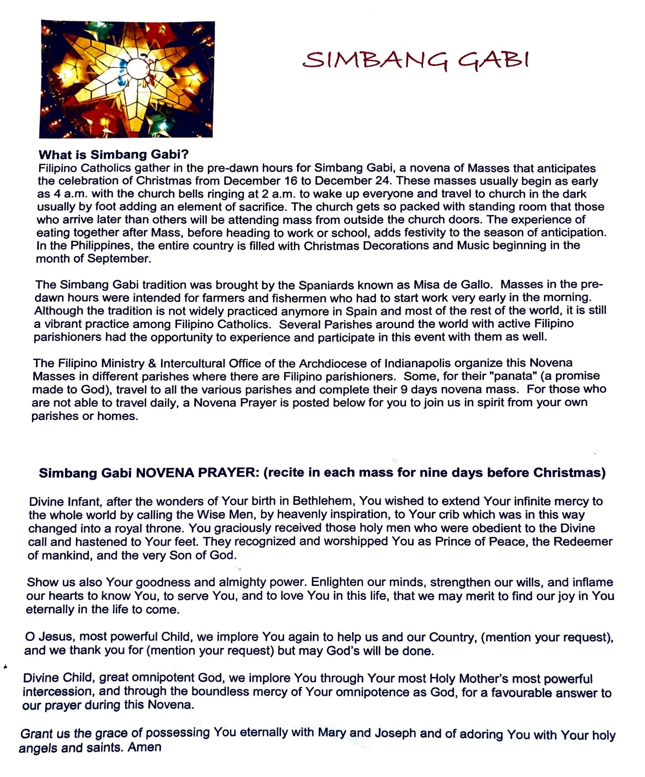**December 16-24, 2021: Philippine Ministry – Simbang Gabi**

For more information contact: Maria Solit0 at [mariasolito@yahoo.com](mailto:mariasolito@yahoo.com)